**Artificial Intelligence**

f



**Benha University**



**Faculty of Computers &**



**Voting System**

**In**

Logic design

**by**

Ayman Mohamed Galal (sec 4)

Ehab Hamed AbdElAzziz(sec 4)

Amr Muhamed Fathy Goma (sec 11)

Mahmoud Ebrahim (sec 22)

**Supervised by** Dr/

**Fatma**

**Ahmed** **Shalaby**

**And Engineer/**

**Aya Abd Elhamid**

*Faculty of Computers & Artificial Intelligence, Benha University*

**Table of Contents**

*1.* Introduction 3

2. Content 4

Conclusion 12

Resources 13

# Introduction

voting systems, where electronics meets democracy! Imagine a setup that makes voting easier, efficient, and reliable. In our voting system, we have some cool electronic buddies - the 4026 IC, 555 timer, 7-segment display, and push buttons - working together to make the voting process smooth.

Now, the 4026 IC is like the brain of our system. It's really good at counting things, in our case, votes. It takes those votes and shows the numbers on a 7-segment display. This display is like a digital scoreboard, letting everyone see the vote count easily.

To keep everything in sync, we have the 555 timer. It's like a clock that ensures the counting happens at the right pace. So, when you press a button to vote, thanks to the 555 timer, the system knows when to count.

And speaking of buttons, we've got push buttons for voters to cast their choices. Simple and easy to use, just like the buttons on your TV remote. These buttons trigger the counting process, so your vote gets included in the tally.

Putting it all together, our system makes voting not only tech-savvy but also user-friendly. It's like having your say in a way that's straightforward and trustworthy. So, with the help of our electronic friends, let's make the voting experience as smooth as pressing a button!

# Content

Voting system can be accomplished using 555 timer to generate pulse on Press Push button at Pins 1 , 2 to be attached to translate the pulse to the (7-segment display).

First the use of 555 timer:

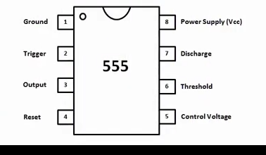

we use **Monostable Timer**

An **Monostable** is a device that has no stable states. The resulting output is **typically a square wave that is used as a clock signal**

The circuit in **PROTEUS:**

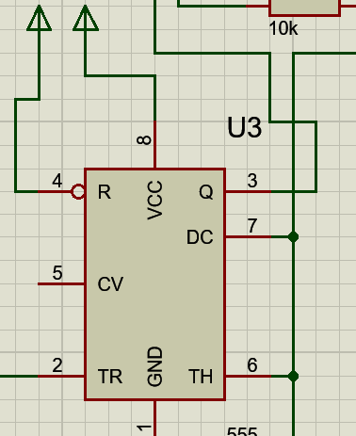

* **The work Idea:**

The output of the 555 timer is attached to Push Button to pulse and add one , and reset Push Button is attached by pins 15, 16 at 4026 IC [Reset] and count again from 0 , we used 2 4026 IC to make it count to 99 sequentially , To Do So we had to connect Pin 5 At first Digit 4026 IC to Pin 1 second Digit 4026 IC

So Now we have a counter from 0 to 99

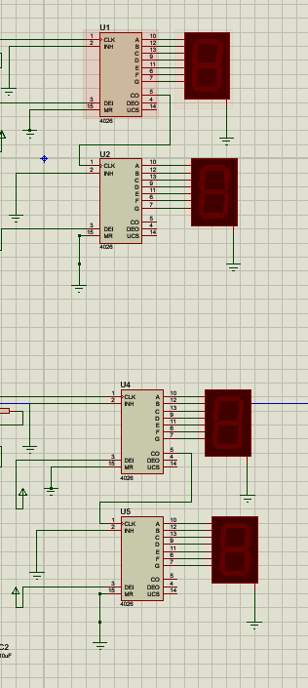

**Experiment Input and Outputs [Tests]:**

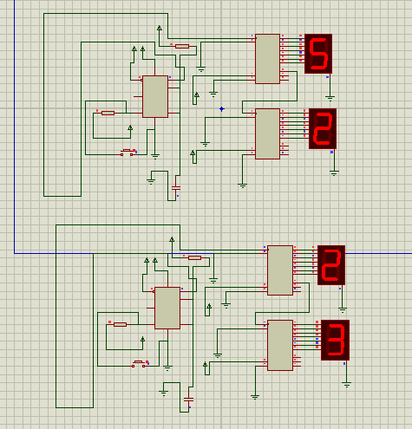

Actually its utilizing push button to display decimals , But still this table **HELPFUL** to understand what is happening under the hood, [as pulses happens]

|  |  |  |  |  |  |
| --- | --- | --- | --- | --- | --- |
| Decimal | D | C | B | A | abcdefg |
| 0 | 0 | 0 | 0 | 0 | 0000001 |
| 1 | 0 | 0 | 0 | 1 | 100111 |
| 2 | 0 | 0 | 1 | 0 | 0010010 |
| 3 | 0 | 0 | 1 | 1 | 000110 |
| 4 | 0 | 1 | 0 | 0 | 1001100 |
| 5 | 0 | 1 | 0 | 1 | 0100100 |
| 6 | 0 | 1 | 1 | 0 | 1100000 |
| 7 | 0 | 1 | 1 | 1 | 0001111 |
| 8 | 1 | 0 | 0 | 0 | 0000000 |
| 9 | 1 | 0 | 0 | 1 | 0001100 |

we don’t Need to do anything in case it reached 9 at first Digit segment display,

as Connect more than one 4026 with other 4026 ic requires connection of pins 1 [Second Digit] and 5 [First Digit]

and which it introduced us into **CASCADING 4026 IC**

**Cascading ICs:**

Cascading ICs, a process of connecting one integrated circuit to another, allows for the collaborative execution of functions or the expansion of capabilities. In this arrangement, the output signals of one IC channelling into the input of another, creating a sequential flow of information. This chaining of ICs enhances their collective performance, enabling the construction of more sophisticated electronic systems. Cascading is commonly employed in scenarios where a single IC's capabilities are insufficient, and the collaboration of multiple ICs is needed to achieve a desired outcome, such as in digital counting circuits, data processing, or complex control systems

**Cascading ICs With 4026 IC:**

Connecting 4026 chips together is like linking them in a chain. By hooking up the 'Carry-Out' pin of one to the 'Clock' pin of the next, you can make them work together to count on multiple displays.



* Full circuit on **proteus:**

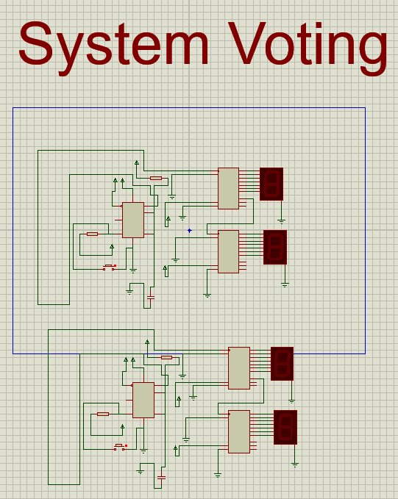

# Conclusion

*This how we built accomplished System Voting using 555 timer , 4026 decade counters and.*

*Then displayed it on 7 segment .*

*And this is how we used logic gates*.

# Resources

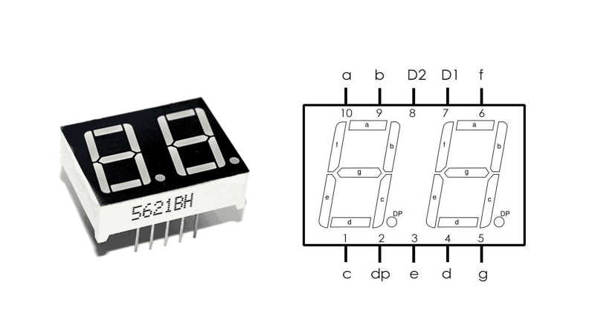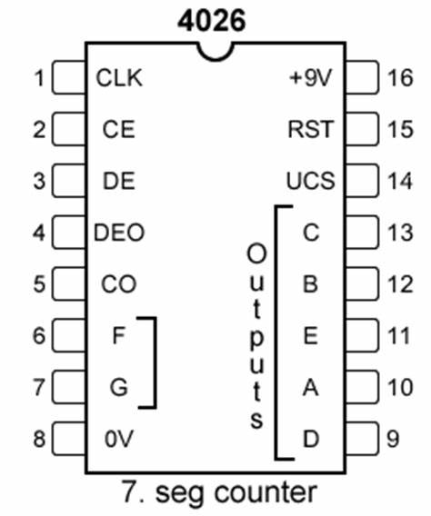

# Full Diagram

